Megha Sharma

1614393

**ASE Lab Assignment-4**

For the assignment one SOAP webservice and a Restful webservice have been implemented and an andoroid app has been developed which makes use of these weservices.

The Android App in addition to these two webservices also uses a number of google’s webservices.

The SOAP webservice has been used to update a local database created in Visual Studio. The parameters for this webservice have been popuated through a JavaScript function which uses callback to populate the results obtained from the service.

The following functionalities have been implemented:

1. Insert Employee Record
2. Select/Display Employee Record
3. Delete Employee Record

A Restful service has also been implemented for user authentication. Ajax call in the JavaScript populates the parameters of the Rest webservice which then verifies the user id and password f the user and if they are correct then displays the name of the user.

Below are the screenshots of the Android App developed

User enters the credentials in the below screen.

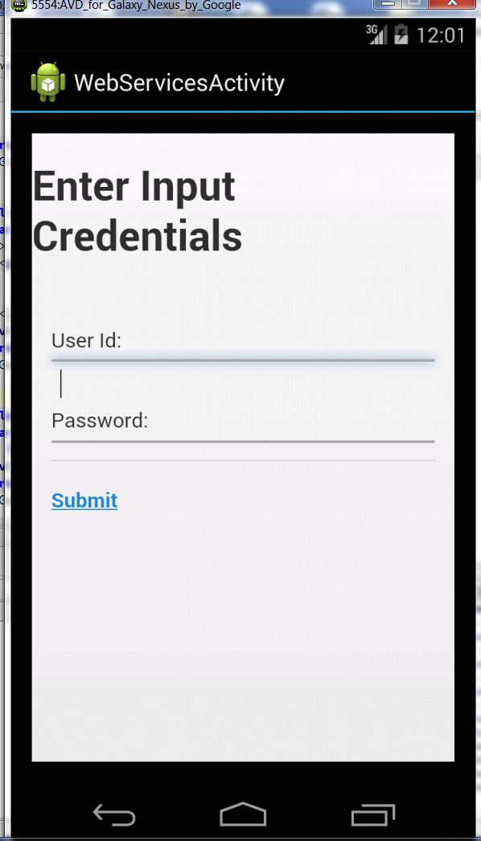

­­­­­­

The user is root and password is root. This is verified by the Rest webservice which returns the name of the user if correct.

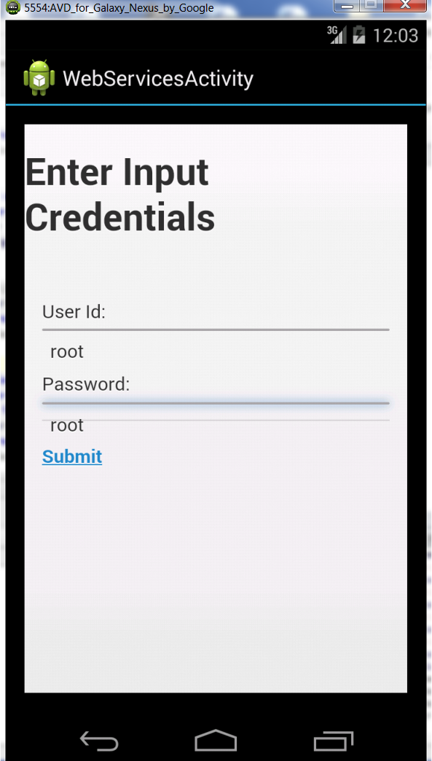

The name “Megha Sharma” is returned by the Rest webservice and it appears next to Welcome.

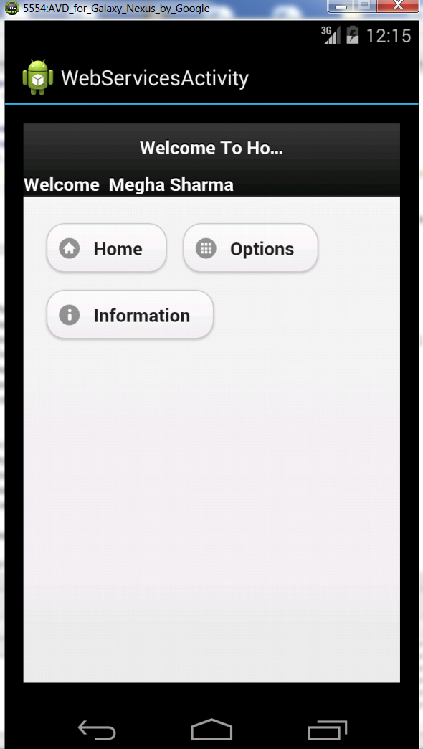

User clicks the Options button

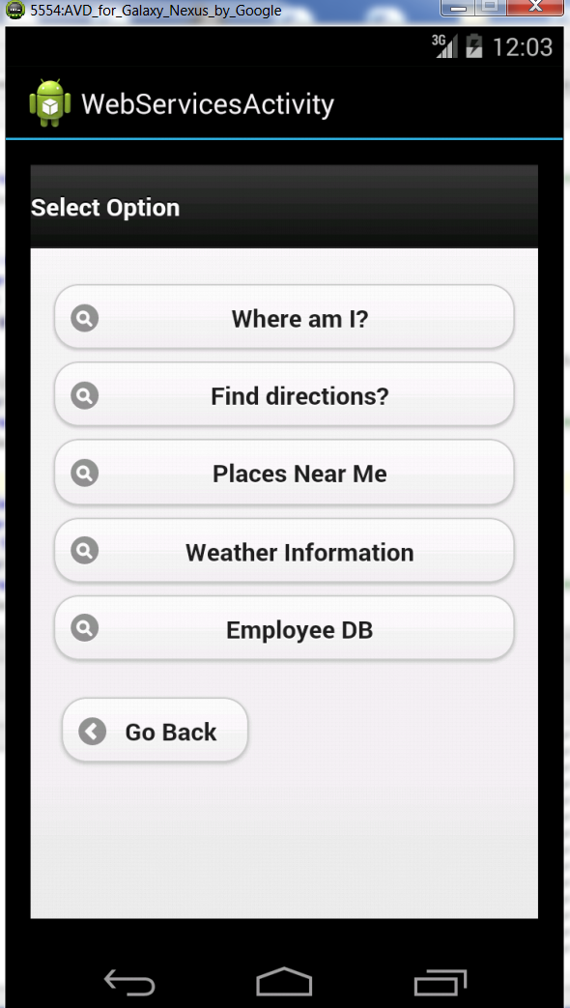

On clicking Employee DB button the various database options are displayed

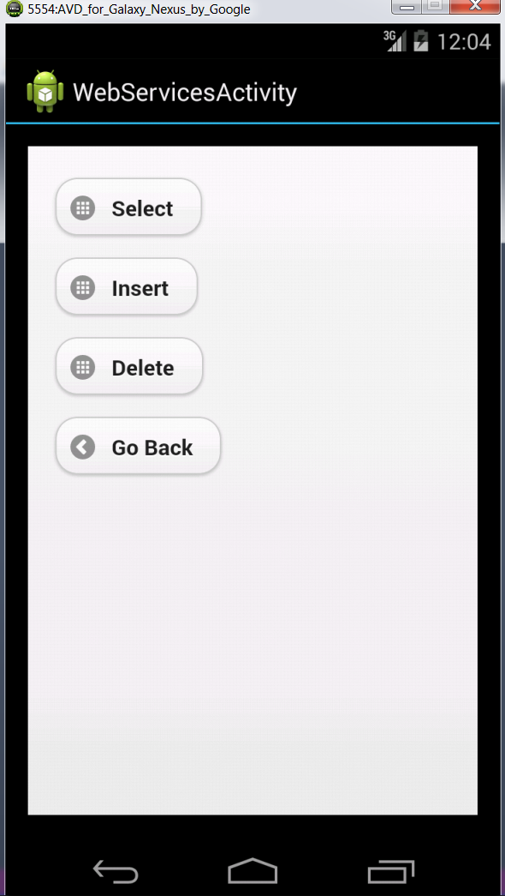

User clicks on Select and enters the name which then gets the record of the corresponding user from the database.

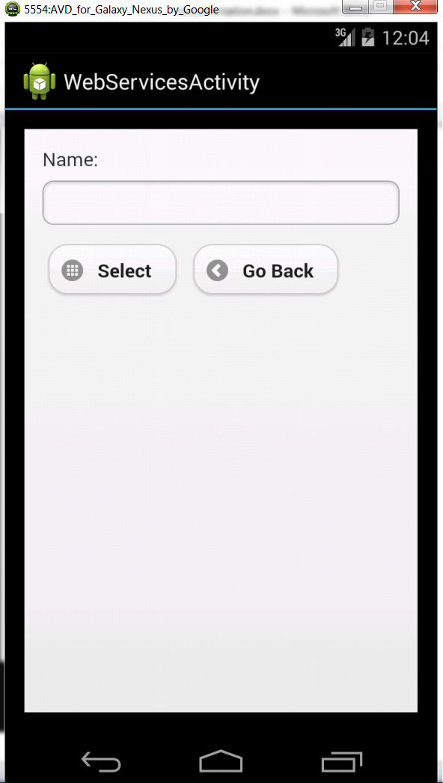

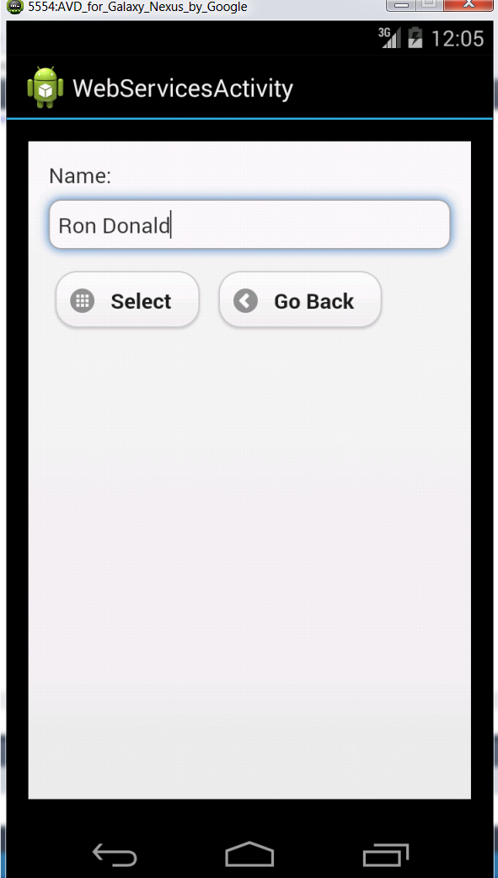

I was not able to host the SOAP webservice completely on IIS server. When hosted through IIS server I am not able to access the local database part and hence the database part of the SOAP webservice is not working with the Android App.

The below screenshots for the database functionality have been taken using the Emulator.

User selects Insert and enters the following details and clicks on Insert.

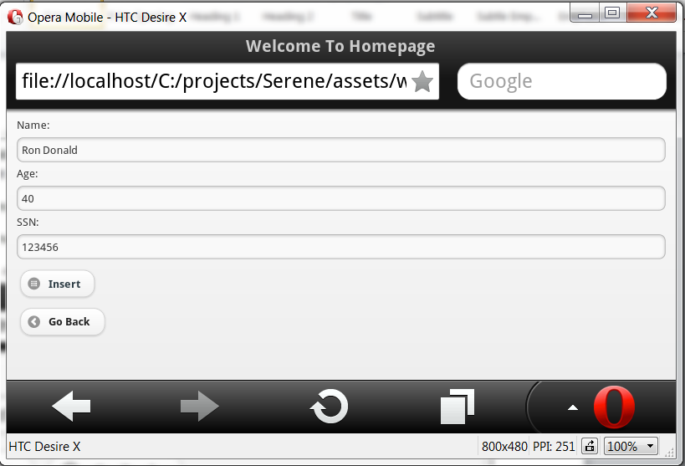

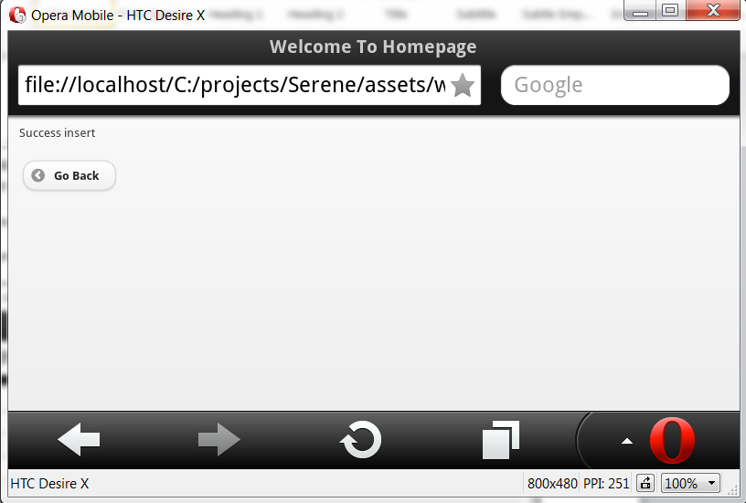

Now user wishes to view the record

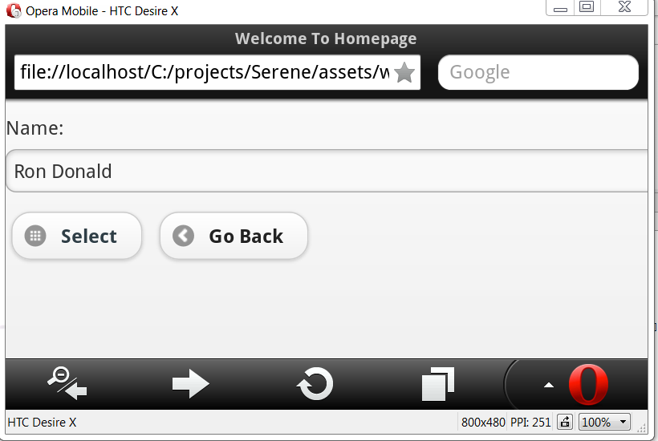

The user record is returned.

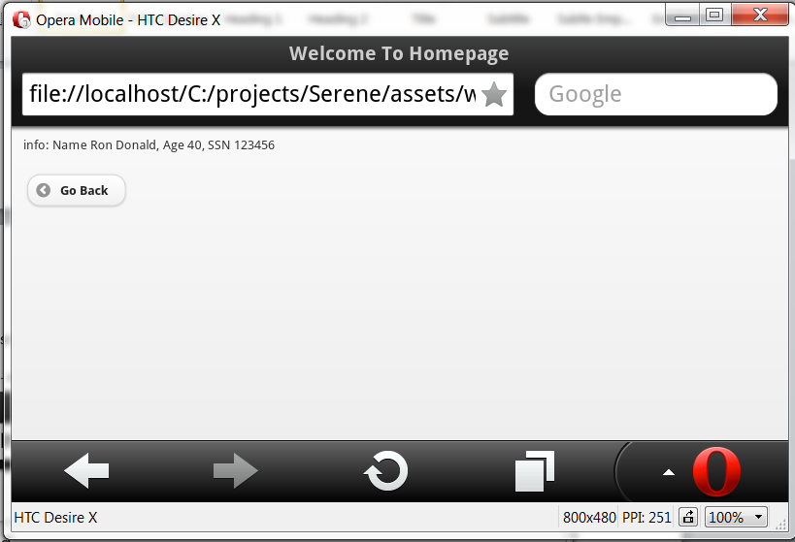

User wishes to delete the same record.

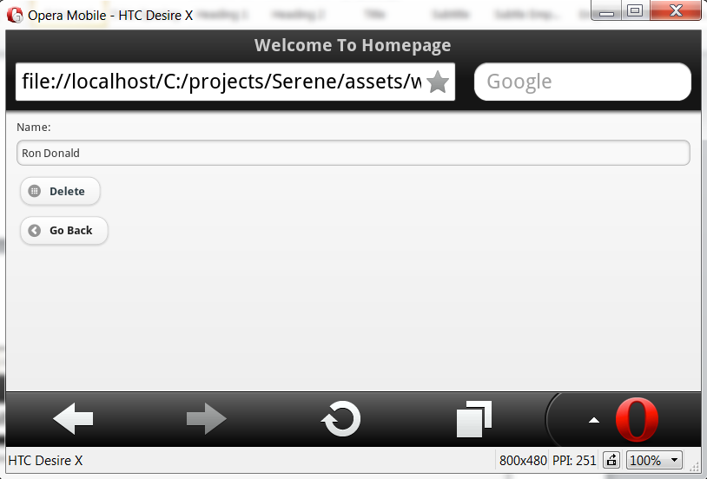

On clicking delete the record is deleted.

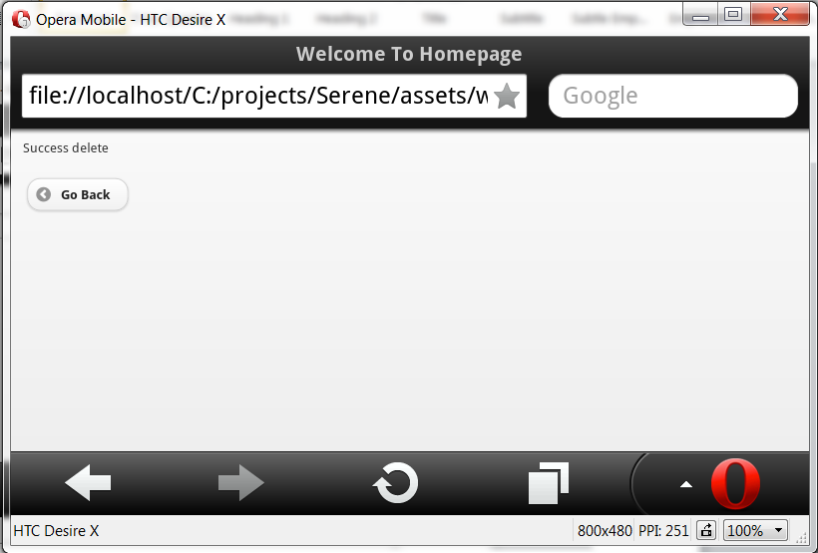

Now on pulling the record again, we get null record since it has been deleted.

